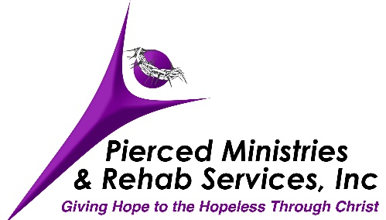

ENTRANCE REQUIREMENTS

Pierced Ministries & Rehab Services, Inc. is a Christ-centered, biblically-based, discipleship program that is focused on helping men and women learn to live in the truth of who God says they are. You should be aware that each step you take with us is designed to help you to develop a heart transforming relationship with Jesus that will guide you into the rest of your life. As you begin this intensive discipleship program, you will need to meet the following requirements:

1. Fill out an application and submit it to Pierced Ministries. You may fill out one on www.pierced4me.org by going to the “Apply Now” link. You can use the fillable application and submit it or print off one and email it for fax it to us. It can be emailed to alice@pierced4me.org or faxed to 336-905-7136. If you need to mail it, the address is P O Box 4669, Archdale, NC 27263. Upon receipt of the application, an interview will be scheduled.

2. We will need proof of HIV, Hep C, and TB tests. Tests that have been completed within the past six months are acceptable.

3. Our normal age group is 21-50. All others must have director approval for admission.

4. We are not a detox facility. It detox is necessary, it must be completed prior to entrance.

5. We do not accept registered sex offenders.

6. We do not accept insurance. Our one-time fee is $500 for men and $700 for women. The fee is due upon entrance and is non-refundable. If you are not able to pay your fee, please advise your director prior to entrance. Although no one will be denied entrance because of the failure to be able to pay, payment will be due prior to graduation.

7. Because we are not a medical facility or a mental health facility, we limit the types of medications that are approved while in this program. The approved medications are generally limited to maintenance medications for conditions such as blood pressure, thyroid, and cholesterol. We do not allow narcotics, anti-depressants, mood stabilizers, medical marijuana, CBD, suboxone, methadone, nicotine cessation products, other MAT treatments, and other medications that we prohibit. We will not tell anyone to stop taking medications that they need; however, we are not the program for anyone that feels that they prohibited medications.

8. Although we are a discipleship ministry, each resident must also be physically able to participate in return-to-work skills. Because this is manual work, we cannot accept people who aren’t able to complete these types of tasks. We are also not able to accept persons who require ongoing medical treatments because we are not a medical facility. No one is allowed to receive any compensation while in the program or have an outside job. Through our work programs, you will develop work skills, work ethics, and learn to work as unto the Lord.

9. For applicants who have an ongoing source of income, such as SSI, tax refunds, retirement money, trust funds, those funds will not be accessible while in the program. Additionally, money, debit cards, EBT cards, credit cards, and other negotiables/valuables are not allowed.

10. For persons who are on probation or parole, please note that the men’s program is in Randolph County. The women’s program is in High Point, Guilford County. Probation or parole must be transferred to those counties.

11. No tobacco/nicotine products are allowed. No tobacco/nicotine cessation products are allowed. No vapes are allowed.

12. We suggest that you have a valid government-issued photo ID and social security card. They will be needed when you begin to transition.

13. Persons coming from jail, detox, or another program must come directly to us. In addition, if you leave detox prior to discharge, you will likely not be admitted here.

14. Men must remove all piercings prior to entry. Women must remove all piercings except for the ears prior to entry.

